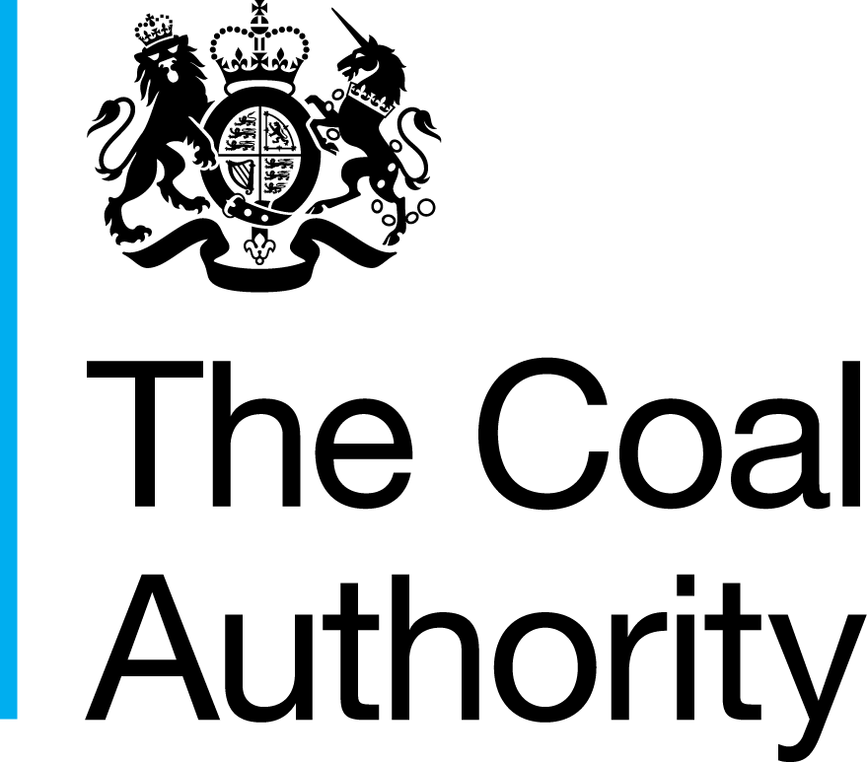

South Staffordshire - Preferred Options Consultation

Contact Details
Planning and Development Team
The Coal Authority
200 Lichfield Lane
Berry Hill
MANSFIELD
Nottinghamshire
NG18 4RG

Planning Email: planningconsultation@coal.gov.uk
Planning Enquiries: 01623 637 119

Date
13th December 2021

Dear Sir/Madam

South Staffordshire - Preferred Options Consultation

Thank you for your notification received on the 21st October 2021 in respect of the above consultation.

The Coal Authority is a non-departmental public body sponsored by the Department of Business, Energy & Industrial Strategy. As a statutory consultee, The Coal Authority has a duty to respond to planning applications and development plans in order to protect the public and the environment in mining areas.

Our records indicate that within the South Staffordshire area there are recorded mining features present at surface and shallow depth including; 465 mine entries, shallow coal workings and reported surface hazards. These recorded features pose a potential risk to surface stability and public safety. It is noted that the mining legacy features recorded as being present are predominantly in the east of the South Staffordshire area.

The Coal Authority’s records indicate that surface coal resource is present in the area, although this should not be taken to imply that mineral extraction would be economically viable, technically feasible or environmentally acceptable. As you will be aware those authorities with responsibility for minerals planning and safeguarding will have identified where they consider minerals of national importance are present in your area and related policy considerations. As part of the site allocation process consideration should be given to such advice in respect of the indicated surface coal resource.

As you will be aware we provide the LPA with downloadable GIS data in respect of Development Risk, and Surface Coal Resource plans. We would expect any sites being considered for allocation to be assessed against this data. Specifically the Development Risk plans as this should enable any constraints and/or issues affecting the site to be identified at as early as possible stage in the process. Where mine entries are present on a site this may impact on the quantum of development which can be accommodated, in order to ensure that these features are not built over, or close to.

In respect of this current consultation the Planning team at the Coal Authority have no comments to make on the specific questions asked in the Preferred Options documents.

Should you wish to discuss these comments further please do not hesitate to contact me.

Yours faithfully

Melanie Lindsley
Melanie Lindsley BA (Hons), DipEH, DipURP, MA, PGCertUD, PGCertSP, MRTPI
Development Team Leader (Planning)

