Draft response to local plan consultation 01/12/2021

South Staffordshire Local Plan
Preferred Options Consultation
South Staffordshire Council
Codsall
WV8 1PX
6 Dec 2021
Dear Sir/Madam
South Staffordshire Local Plan: Preferred Options Consultation 2021

Response from Kinver Parish Council
We are writing to present Kinver Parish Councils response to the South Staffordshire Local Plan Preferred Options consultation.
We welcome many aspects of the South Staffordshire Local Plan and the planning framework it sets out. We especially welcome the emphasis on Climate Change measures, and the stance taken by the Local Plan to go beyond government minimum requirements.
However there are some issues where we believe the Plan needs updating with new information and policies; some where we believe policies have been mis-applied; and some where we believe a better outcome could be obtained with more site specific information related to Kinver, or a modified approach. In particular, we consider that the justifications for building on green belt and farm land are insufficient; and that the transport and infrastructure implications have not been adequately addressed.
For the purposes of this representation we deal with each point in turn and would welcome a discussion relating to the points raised below.

Basis for Housing target numbers

1.a. Growth Strategy Indicative Housing Figure
Excessively pro-growth strategy without recognising the constraints of the area: The South Staffordshire housing number is biased upward
We believe that the South Staffordshire housing number, at almost 5000, is too high and should be recalculated with
- It already includes a 26% uplift because house prices are high in this area.
- Full allowance for housing achieved which is not included in the Plan’s calculation
  - Recent average windfall of ca 200 per year (Housing Monitoring 5YHLS 2019-2020 Final.pdf, p9) has rivalled Plan allocations in size. The discounting of this figure to 30 p.a. is not properly evidenced, and runs counter to current continuing experience.
  - Allocated sites typically achieve 25-50% more housing than the minimum included in the calculation.
  - By ignoring these sources yet permitting their continuance, the Plan is causing housebuilding far beyond the calculated “need”.
- Use of updated population trend data reflecting slowed growth (ONS).

The calculation approach will inevitably result in build far beyond Plan numbers
- By failing to fully allow for windfall and the additional housing above the minimum on allocated sites, the plan is excessively pro-growth and causes build far beyond calculated need. This is counter to sustainability, climate change and green belt policies.
- A method for adjustment of housing numbers during the life of the Plan is required should windfall and build-out levels continue at levels above those used in the Plan calculations.

The 4000 additional housing number under “Duty to cooperate” is excessive for South Staffs to absorb, and is not proven:
- The 4000 homes accepted from the conurbation councils effectively double the actual need calculated for South Staffordshire. They are too many to absorb.
- The GBHMA should be strongly encouraged to review its numbers with recent information (e.g declining population growth, changing national policies); and to maximise brown field site use as now required. The LP PO document states that these numbers are under review. Dudley council pledged in 2021 to maximise use of brownfield to protect their own green belt, as did Birmingham. The figures do not yet reflect these changes.
- We understand the concept of duty to cooperate, but here it is resulting in development predominantly on green belt and valuable (grade 1-3) agricultural land, contrary to NPPF policies
- Part of the GBHMA housing number is an arbitrary additional housing requirement placed on Wolverhampton to achieve the government’s current naitonal target of 300,000 per year. This was expressly intended to revitalise urban centres and use urban/brownfield sites. If it is not required by Wolverhampton, it should not be exported to rural areas under duty to cooperate.
- Has South Staffordshire sought cooperation from other local councils as required by the NPPF (para 141) before taking land out of Green Belt?

The attached “ASSESSMENT OF HOUSING PROPOSALS: LOWER PENN” gives a more detailed analysis of the housing number evidence base, and concludes: “ the housing numbers in South Staffordshire, particularly the uplift of 4,000 to meet Black Country need is not justified”. This document draws on the Black Country Urban Capacity Update June 2021 cpre assessmenet.pdf, which is also attached.

The Plan will result in build far exceeding need, with substantial adverse impacts on the environment; on plans to limit climate change; and on infrastructure. None of these is adequately addressed in the Plan. (See below )

1.a.i Kinver housing needs:
- The housing allocation is too high, representing an increase of population (or of housing replacement rate) of about 7% (254 homes) on a parish with static or falling population (ONS). We cannot defend this on the basis of local need.
- Kinver can provide for more than the allocated housing need from windfall and brown field sites. (Recent windfalls have averaged 35 per year. The SHELAA 2018 cites 32 units with planning permission in Kinver parish at that time, in addition to allocated sites. The Plan asks for <8 units per year from 2021-2037 )
- Despite this evidence, the Plan allocates 2 new green belt sites and intends to develop a further green field / ‘safeguarded’ site of exceptionally high environmental and community value.

1.b Adverse consequences of a too-high Plan housing number

Building too many houses, and building them in rural areas, is counter to government and council policies on climate change , green belt protection and the environment
- We understand that government are ‘clear’ that building houses is a priority to boost the economy.
- But this policy, and particularly when applied in rural areas, and on green field sites, is counter to more recent policies, including those on Climate Change ( reducing car use, avoiding ploughing out green pasture etc); and on prioritising Green Belt protection (NPPF).
- Council should review the number in the light of updated information; and must ensure that location and other factors are chosen to minimise conflict with current and emerging national policies on climate change and green belt.

Green belt release is not needed for local housing
- We believe there could be sufficient development land in South Staffs to meet the local need, (without Green Belt Land) if the ‘need to cooperate’ were removed and the local calculations were reviewed to remove upward bias. (see attached document)
- We do not consider that the necessary ‘exceptional circumstances’ have been met, as required by the NPPF, to justify taking land out of green belt, or removing agricultural land .
- Despite the words, ‘biodiversity net gain’ cannot compensate for the scale of loss of green fields and wildlife sites in this plan.

Avoid over-delivery by correcting the Plan’s built-in ratchet mechanism
By basing its calculations on minimum site numbers, and under-allowing windfall, the Plan will inevitably overdeliver by typically a factor of 2. We suggest that two strategies for avoiding upward creep are:

- Allow for windfall. Put forward a clear policy on windfall allowance and adjustment in calculations, and during the Plan.
- Provide a clear policy on maximum build densities. We welcome the commitment by SSDC to creating good places to live, and the indication at a recent webinar that building only the minimum number on a site, leaves space for this, through street trees, green space, biodiversity gain, and so on. We need clarity in the Plan to make it happen.

Release sites slowly, and green belt/green field sites last, to reduce Green Belt loss and planning blight in case demand does not materialise.

If greenbelt and safeguarded land are deemed essential, delay their release until well after other land has been used. Demographic, economic and politico-legal conditions, and therefore housing need, are changing. It’s possible this land won’t be needed, after all, delay gives a chance to save it.

Climate Change
We welcome the importance placed upon climate change in the Plan, in line with national priorities, the Climate Emergency acknowledge by South Staffordshire in 2019, and the Climate Action Plan subsequently developed. The Local Plan is a vehicle to deliver positive design solutions and create ‘sustainable places’.

The Climate Emergency requires prompt, effective action – delay will result in disastrous, unpredictable and uncontrollable consequences. The time-critical nature of the emergency means reduction in carbon emissions must be prioritised.

We therefore note and welcome the Local Plan statements:
“We will use the planning system and the new Local Plan as a vehicle to encourage sustainable
patterns of development, promoting carbon resilient design, and protecting the natural
environment.”
“The overall spatial strategy in focusing greater levels of development in the larger villages and urban edge locations with greater access to facilities and public transport, thus reducing car dependency, is key to achieving sustainable development and tackling climate change.”

However we feel that central aspects of the plan militate against these objectives:

2.a. Taking GBHMA housing into rural areas increases Carbon emissions:
- Bias towards over-delivery of homes will increase carbon emissions - by the build process and by destruction of green land. Instead, develop climate change initiatives to contribute to economic growth via e.g. retrofit or renewable energy projects.

- The relocation of GBHMA homes to rural areas will more than wipe out the Climate Change measures in the Plan such as reduced-carbon building methods.

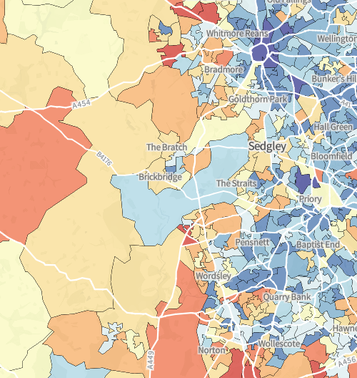

Map: relative carbon emissions, urban v rural W Midlands. Brown = high. (www.carbon.place)

2.b. Kinver parish: Climate Change Issues:.
Car use
- Allocating housing in Kinver is counter to national and SSDC policy of building in larger, well-serviced centres to reduce carbon emissions.
- Kinver has negligible public transport. The bus service cannot be used for commuting to work; for visiting the main GP surgery eg for Covid jabs; for getting to hospital; or for visiting council offices and services.
- The ‘sustainability assessment ‘ of sites was carried out AFTER application of the site location strategy (Tier system). This effectively excludes sites which may be closer to services in the conurbation, and have a lower carbon emission impact, than sites on the edge of Kinver settlement.
- The suggestion of new cycleways and Active Travel is welcomed, but realistic cost and feasibility, strategy and funding source are not clear.

Flooding
Both river flooding, and storm (‘flash’ ) flooding, are increasing in frequency and extent under climate change.
- River flooding: We need mapping of the worst case Climate Change scenario for flooding to avoid future problems. Table 5 of the LP-PO document mentions only Penk and Smestow rivers as draining south Staffordshire. Kinver is on the Stour. It appears that updated climate-change modelling has not been undertaken for the River Stour. Please can this be rectified.
- River flooding in Kinver already threatens the Community Centre and housing including the High Street. Recent planning permissions have allowed building very close to the current flood line, such that they are likely to be at substantial flood risk within the near future.(see below).
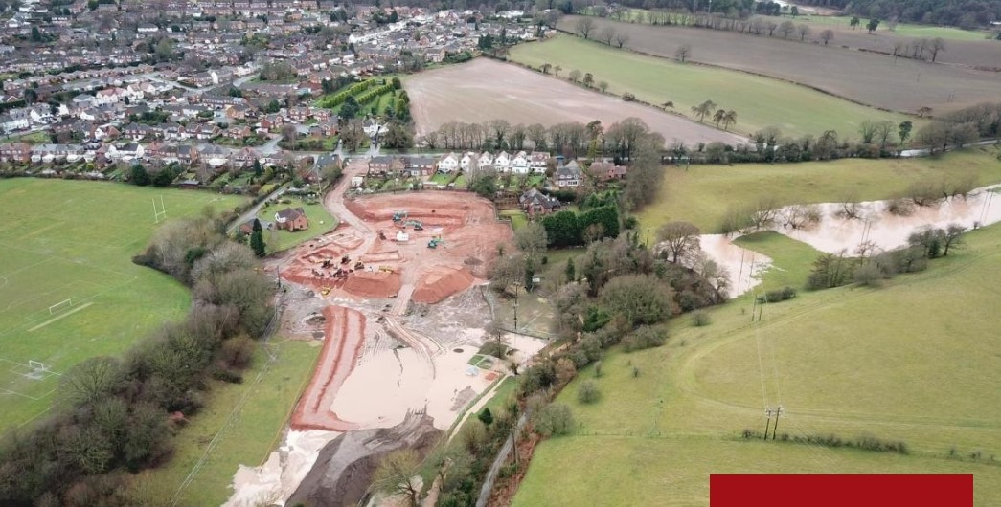
Photo: Recent flooding on new housing site 270, Hyde Lane, Kinver. Proposed site 576 is on the slope beyond site 270 (bare soil).

- Stormwater flooding: The 3 proposed sites in Kinver, and the two recently granted planning permission (270, 274), are all on previously green land which absorbed rainfall. All but 1 are in the Potter’s Cross/Hyde Lane area which feeds Mill Brook (photo above) , thence the Sterrymere, and adjacent Community Centre (KSCA) all of which flood regularly. Development on these sites risks increased flooding, which will be exacerbated by Climate Change. What modelling/assessment has been done, and what plans are in place to prevent stormwater floods, given that SUDS are only partially effective?

Transport and infrastructure

The proposed Plan indicates will result in a greatly increased population growth relative to the expected rate predicted from demographic data.

3.a. Infrastructure implications
- Transport impacts will be immense. What are the infrastructure plans and who will pay for them? The allocations are not supported by transport assessments.
- Growth focussed along the A449 corridor (in Worcestershire as well as Staffordshire) will cause jams at local junctions and problems for commuting into the conurbation.
- Rural expansion will aggravate the over-use of narrow rural roads never designed for this.
- Existing public transport infrastructure is inadequate, few settlements have rail with adequate parking; most bus services are inadequate for commuting and accessing services.
- How will these homes be ‘sustainable’ when most will require 2 cars to access employment and services.
- How will the settlements themselves absorb these extra homes and provide the local services and infrastructure they need.

What contribution will be made by the GBHMA towards the cost and integrated planning of infrastructure to serve the population being relocated into South Staffs? The infrastructure cost will be far greater than if built within the conurbation. It seems essential that the ‘duty to cooperate’ should include adequate contribution to resulting infrastructure, but the Plan gives no assurance.

3.b. Kinver Parish : transport and infrastructure

- The Plan contains no discussion of how the increased traffic and other service requirements from new housing will be dealt with in Kinver parish, nor how it will be funded.
- Local traffic: The scale of building proposed will create pressure on roads. Traffic in Kinver is already congested – the High Street frequently grinds to a halt, exacerbated by delivery lorries navigating a restricted width. The Potter’s Cross junction by schools becomes dangerously congested at busy times; and the few back-route alternatives are largely single track and hilly.
- Proposed allocations will further exacerbate current pinch points at Potter’s Cross and the High Street in Kinver.
- Road and footway capacity could be difficult and expensive to increase in Kinver due to constraints of hills, river and canal, narrow lanes and conservation areas.
- Expanded road systems could damage the appeal of an area which has great importance for open-air recreation to surrounding areas.
- The commitment to encourage provision of cycle routes is welcomed. Given the practical difficulties, we would like to discuss realistic options with Council.

- Major routes: The A449 Stewponey junction, at Stourton, through which most Kinver traffic passes to reach the employment and services of the conurbation, already jams at peak periods and weekends. The many developments being planned near the A449 will increase congestion.

3.c Kinver Services:
- Kinver is stated to be a Tier 2 village, - it has a secondary school. However our services and facilities are far below the average for Tier 2. This must be taken into account in allocating housing.
- The information given about Kinver services in Plan supporting documentation is incorrect. E.g. We have no leisure centre, only one small supermarket, only one GP surgery which is struggling to provide a full service in Kinver. Our limited bus service is inadequate for commuting, getting to local colleges, hospitals, or the main doctors surgery, or indeed getting to anywhere but Stourbridge in the daytime.
- We want to work with you to update the information and discuss the implications.

3.d CIL and S106 developer contributions:
- Can the Council explain why they are not pursuing the CIL model, to provide funding for the essential infrastructure The two are treated as complementary rather than mutually exclusive by many councils, and we understand that the CIL would add transparency and flexibility.

- Could the council further explain how funding for general infrastructure improvements will be generated; and how they plan to actively consult with local parishes to ensure that the infrastructure provided meets local needs?

Site allocations in Kinver

4.a Green belt contribution and justification for sites
- The 3 new sites proposed in Kinver are green field – either Green Belt or recently released from Green Belt - and contribute to the purposes of the Green Belt. (See table below).
- National and local policy is to re-use existing sites , or at worst use other land, before Green Belt release. The need for Green Belt release, has not been proven
- We do not consider that there are now, or have ever been ,the necessary ‘exceptional circumstances’ to justify the release from Green Belt for development, since other options exist.
- The Local Plan’s Housing Topic Paper 2021 para 3.6 says that:” site suggestions that are predicted to have major negative effects under the landscape criteria due to being in more sensitive areas within the Green Belt Study 2019 and Landscape Sensitivity Assessment 2019 …. have not been treated as a significant constraint on development.” This appears to negate the importance assigned to landscape in NPPF and policy generally.

Green Belt Purpose (NPPF 2021) | Site 576 / 271  Hyde Lane | Site 272  Dunsley | Site 274 (safeguarded)  White Hill
- Check urban sprawl | V High | V High | V High
- Prevent towns merging | Mod | Mod | Mod
- Safeguarding countryside from encroachment | V High | V High | V High
- Preserve setting an special character of historic towns | High | V High | V High
- Encourage recycling of urban land | High | High | High
Landscape sensitivity | High | V High | V High

- The 2 new Green Belt sites contravene NPPF paragraphs 140 and 143 that “Strategic policies should establish the need for any changes to Green Belt boundaries having regard to their intended permanence in the long term, so they can endure beyond the Plan period”, and that if removed, councils should “define boundaries clearly…likely to be permanent”, since both are contiguous with a large area of land identified on the SAD, without natural boundary, thereby positively inviting sprawl beyond the bounds of the sites. Indeed Site 576 has simply been cookie-cut from the middle of a much larger SAD field, in such a way as to make continued farming of the remainder very awkward.
- The published Green Belt assessments appear not to have noted the topographic element of the value of a site. Kinver sits in a ‘bowl’, largely protected from view from the surrounding Green Belt countryside. All the sites proposed for Kinver would damage that setting.
- All 3 sites are contrary to the NPPF policy that priority for green belt release should be of land well served by public transport.
- The target of 10% of homes on “smaller sites is not adequate justification for taking land out of Green Belt in Kinver. (NPPF)

4.b. Loss of green space and amenity for South Staffordshire
- Kinver is the most visited outdoor recreation area in South Staffordshire. People come to walk, cycle, ride and enjoy the beauty of the location. More than 69,000 visited the National Trust rockhouses just above the village last year – and the NT estimate 250,000 visited the adjacent Kinver Edge ridge, (an SSSI), with its hill fort, woods, lowland heath and views. Visitors enjoy the views and the sense of openness that the Kinver Edge and surrounding green belt afford, and the views of the village nestling in its valley site. Many visitors also come via the canal towpath, and wander on to enjoy Kinver village and the local canal, river and heritage of the conservation area.
- This amenity is being eroded and damaged by continual development. The Local Plan makes no proper assessment of the potential impact of continued development on wildlife and amenity here.
- All proposed sites contravene NPPF policies para 174 and 179 that sites with wildlife, biodiversity geodiversity, priority habitats, and ecological networks should be protected and enhanced.
- South Staffordshire’s policy of placing development adjacent to ’Tier 2‘ settlements here has the unintended consequence of damaging a major local attraction and precious rural heritage asset. Kinver parish’s heritage, wildlife and landscape attractions are concentrated around Kinver settlement. By over-expanding Kinver, the essence of a valued place is being lost.

We ask for a detailed discussion with SSDC on the Site Allocations, as we believe there are better solutions than the Plan proposals.

4.c. Site 272: Dunsley: (Green Belt)
The evidence base supporting this allocation does not provide a clear planning rationale to warrant the release from the green belt for the following reasons:

This site contributes strongly to the major purposes of Green Belt.
- It checks the unrestricted sprawl of Kinver. Development of this site would breach a natural boundary to the village (it’s at the brow of the valley in which Kinver lies, and bounded by a road). The site has no strong boundary from the rest of the Green Belt, which is elevated land . It would open the way to highly-visible sprawl across the green belt towards Stourbridge/ Black Country.
- This site, being at the crest of a rise, will damage the openness of the Green Belt beyond, by creating an urban view, instead of a tree-lined horizon with church in the distance.
- It helps safeguard the countryside from encroachment.
- It preserves the setting and special character of Kinver, and the landscape and buildings around the site are a part of that historic fabric. It is adjacent and linked by paths to the Conservation Area.
- Alternative land exists in the area which could easily be recycled or enhanced to provide the allocated number of homes without ploughing up green field.

Other Concerns:
- Flood risk: The raised site will increase the risk of heavy rains flooding the existing properties. It is not clear how this increased flood risk from new housing could be effectively prevented.
- Conservation Area and visual amenity: The site adjoins the Canal conservation area. It is adjacent to several old farm buildings and houses, and accessed by well used local footpaths. Development would damage visual amenity and enjoyment of the views over the valley within which Kinver sits.
- Access and infrastructure: it is not clear how the current narrow, restricted access could be enlarged to accommodate additional housing.

4.d. Site 576 (part): Hyde Lane: (Green Belt)
The evidence base supporting this allocation does not provide a clear planning rationale to warrant the release from the green belt for the following reasons:
- We do not think that exceptional conditions have been demonstrated for release of this land from Green Belt. Other sites including brownfield sites and sites less damaging to the green belt are available.
- We believe that this site contributes strongly to the major purposes of Green Belt.
- It checks the unrestricted sprawl of Kinver. Development of this site would breach a natural boundary to the village (trees and topography) and open the way to highly-visible sprawl across the green belt towards Stourbridge/ Black Country. Indeed the site has been cut in an awkward way from a large field (Site 271), such that the remaining land would be difficult to farm efficiently. This is in clear contravention of NPPF guidance.
- This site, by extending the visibility of Kinver from the north, will damage the openness of the Green Belt,
- The site helps safeguard the countryside from encroachment. If developed, the lack of boundary means further development across countryside is effectively pre-determined.
- It contributes to the setting and special character of Kinver, largely within a bowl which hides it from much of the surrounding countryside
- Alternative land exists in the area which could easily be recycled or enhanced to provide the allocated number of homes without ploughing up green fields

Other Concerns:
- Loss of agricultural land: The site is productive arable land, producing food and should not be taken from the green belt. It would be contrary to Green Belt policy GB1.
- Flooding.: Development would create storm water flows onto Hyde Lane forming a flood on the road, then into the field below, thence Mill Brook and Sterrymere and into the Stour. The risk of flood of the Community Centre building (KSCA) and Marsh Playing Fields will be greatly increased. SUDS are unlikely to be adequate to prevent this in heavy rains and wet periods.
- The shape of the development makes no sense as an adjunct to Kinver.

4.e. Site 274 (part): White Hill 2: (Safeguarded land)
The evidence base supporting this allocation does not provide a clear planning rationale to warrant the release from the green belt for the following reasons:
- We consider that the original case for taking this land out of Green Belt was seriously flawed and contained inaccuracies. It also failed to take proper account of the site’s value to the community, its wildlife value, and its landscape value in relation to Kinver Edge and its setting.
- We consider that the site continues to contribute to the purposes of green belt, wildlife, community, landscape and heritage
- Although it looks like infill on a flat map, when viewed in its Kinver Edge context and with local knowledge of its use, it reveals itself as a valued and critical component of the natural landscape for which Kinver Edge and our parish are so widely appreciated.
- We believe less damaging locations can be found to achieve the SSDC purposes. We would welcome discussion with SSDC on alternative options and/or minimising damage.

Wildlife
- This is a former wildlife site, adjacent to National Trust woodland which abuts the Kinver Edge SSSI.
- It is a critical part of the wildlife corridor between Kinver Edge and Highgate Common, currently being enhanced under grant funding (SWT, NT and others). At this point the corridor is especially narrow and Staffordshire Wildlife Trust have said the site is particularly valuable for this purpose.
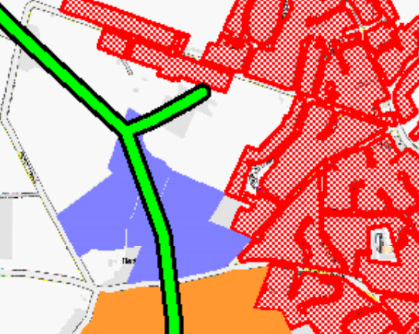
Above: Wildlife corridor map (green routes) around site 274 (Centre of map). Source: Staffordshire Wildlife Trust

- Ploughing out the old unimproved grassland which constitutes the southern part of the site would create a huge release of carbon dioxide. Yet it is identified by SWT as the ideal soil type and location for development as species-rich pasture, or even restoration to lowland heath, creating substantial biodiversity gain.
- In short this is a prime site for Nature Recovery, biodiversity gain, and enhancement of wildlife value, and should be retained for these purposes.

Community value
- The site is very much used and appreciated by local residents for walking, exercising dogs, enjoying the scenery, and accessing surrounding landscape. It is THE site for sledging within the village. It has been used for village events when the Marsh Playing Fields are flooded.
- In the recent Questionnaire in relation to the Neighbourhood Plan, this site came out most strongly for its value as a green space for the community with over 80% rating it Important or Very Important. It is accessible to the village, and a valued green space.
- More than 90% also rated protection of views from Kinver Edge as Important or more – and these views would be damaged by this development. Many respondents in addition cited their reasons for valuing the area – walking and dog walking, of course; view, proximity to lovely woodlands and the Edge; wildlife including raptors, and bats in the evenings; and – over and over again – sledging

Staffordshire way
- The long distance footpath Staffordshire Way begins on Kinver Edge, and as it drops off the Edge, passes into this site. National policy is to maintain the openness of such paths. We support this strongly, particularly because of the lovely views of this walk, and the fact that we are so near its start.
- Openness would be best achieved by leaving it as it is, which would give potential to enhance the wildlife corridor (see above). As a worst case, a wide corridor must be left, including the hill, for biodiversity , community and landscape purposes.

Landscape value
- Development here damages viewpoints from and to Kinver Edge (NT), which has always been a planning concern of SSDC. It also damages the view from the western part of the village towards the Edge. Far from being unobtrusive ‘infill’ , this site will damage an important visual part of the setting of the Kinver Edge and Kinver.

Conclusion
In conclusion, key issues are
- The sites identified in Kinver are not required to achieve its housing need
- Removal of land from the Green Belt is premature since exceptional circumstances have not been established
- The Plan’s Housing Numbers are excessively high and unjustified by current evidence or policy.
- Inadequate evidence is provided on climate change impacts of the Plan – including on car use, transport and construction-associated emissions
- Inadequate evidence is given on transport and infrastructure requirements, and their funding.
- Location policies, and in particular relocation of GBHMA housing to rural sites, are unsustainable in terms of services and infrastructure; Climate Change; and green field site preservation.

We look forward to receiving your comments.
Yours faithfully

Pp Kinver Parish Council

Appendices/ attached:
- Assessment of Housing Proposals, Lower Penn_2021
- Black Country Urban Capacity Update June 2021 CPRE assessmenet.pdf

