**Nurton Developments Limited**

**Land at Junction 11, M6, Hilton Park**

**Representations to South Staffordshire Local Plan Pre-Submission Draft (Regulation 19)**

**Paragraph 6.41-6.45**

**Policy SA7: Employment Allocations**

**Box 5 - Reasons for Unsoundness**

***Summary***

1. Policy SA7 only allocates sites forming part of the existing land supply (i.e those which are already allocated or consented). This is said to be justified on the basis that there is a surplus of employment land to meet local needs (36.6 hectares), with this surplus comprising an appropriate contribution to meet wider unmet needs, i.e those from the Black Country.
2. JLL’s representations in respect of Policy DS4: Development Needs considers that the need for employment land has been purposefully and significantly understated and that the supply has been substantially overstated, leading to a wholly distorted picture of the balance between local need and supply. Instead of a surplus, JLL considers there will be a shortfall of at least 90 hectares. The plan is presently unsound on this basis.
3. Qualitatively, there is also an urgent need to bring forward new strategic employment sites to meet the wider needs of the Black Country and South Staffordshire. This need has been identified by the West Midlands Strategic Employment Sites Study of 2021. An update to this study has just been commissioned on the basis that the contents of the original report have been largely ignored by a number of local authorities.
4. In this context, Policy SA7 needs to identify new sites which will fill the gap across the FEMA, both quantitatively and qualitatively.
5. JLL considers that the potential strategic employment site at Hilton Park at Junction 11, M6, is best placed to help fill this gap. It is an obvious reasonable alternative freestanding strategic employment site in terms of its location, its relationship to planned infrastructure improvements (i.e the M54/M6 link road), its achievability in market terms, and its ability to meet the criteria set out by the West Midlands Strategic Employment Sites Study.
6. Unfortunately, this opportunity has not been recognised by the Council. JLL considers its assessment of the site (Ref No: E43) has been seriously flawed, with this being a failure of both process and judgement.

***The Opportunity at Hilton Park, Junction 11, M6***

1. The site has a gross area of 99.23 hectares (245 acres). This reduces to 75.69 hectares (187 acres) once land acquired by the Secretary of State for construction of the DCO approved M54/M6 link road is taken into account. The actual developable area nets down to 43.10 hectares (106.5 acres) to ensure sufficient land is provided for blue and green infrastructure following detailed consideration of the constraints and opportunities the site affords and taking account of statutory requirements.
2. In market terms, the site enjoys many significant advantages. These include:-

* Located directly to the southwest of Junction 11 of the M6 motorway.
* Direct access to the A460, which connects to the M6 at Junction 11.
* Easy access via the A460 to the Pentalver Rail Freight Interchange at Cannock and to the proposed West Midlands Interchange at Gailey (Junction 12, M6).
* Easy access to the approved M54/M6 link road via Junction 11 M6, leading to J1 M54
* A location accessible to the principal settlements in the area (i.e the Black Country, Cannock, Stafford and Lichfield), giving good reach to the local labour supply.
* A regular shaped site with good prominence to the M6.
* A large sized site that can accommodate a critical mass of buildings, ranging from 5,000 sq ft to 250,000 sq ft, totalling up to 175,000 sq m (1.9 million) sq ft across B1, B2 & B8 uses

1. The locational advantages of the site will be further improved when the proposed M54/M6 link road is built and operational. Indeed, it will become one of the best industrial and logistics sites north of the Birmingham conurbation. Construction is due to start in early 2023 and the road should be operational from 2025. This link road will significantly increase road capacity on the A460 and will make Junction 11 a strong nodal point on the national and regional motorway network, providing a crossroads connection to the M54, M6 and M6 (Toll).
2. The site is free of major constraints. There are no obvious physical limitations or issues such as access that cannot be mitigated satisfactorily. Aside from the policy constraint of Green Belt, which restricts any development outside the built-up area of the Black Country, including much of South Staffordshire, the site is not designated by the adopted Local Plan for any landscape or conservation purposes.
3. As set out below, what is inexplicable is that the Council has consistently and repeatedly refused to update their green belt evidence base to take account of this very significant changed status in this site as a result of the DCO.
4. In August 2020, JLL produced a Technical Note on Deliverability of the site. This was submitted to the Council. A copy of this Technical Note is provided as an enclosure to this representation (**Enclosure No. 1**).
5. The Technical Note illustrates the latest thinking on the opportunity for development of the site and demonstrates that the proposed scheme is deliverable. The Technical Note is supported by detailed assessment and analysis from a number of expert consultants covering transportation, drainage, ecology, utilities and services, topography, and master planning. Specifically, it addresses: -

* The impact of the M54/M6 link road on the development of the site.
* How to retain the more valuable ecological features of the site, mitigate for any loss, and manage a net gain in terms of biodiversity.
* How best to drain the site using SUDs.
* The creation of development plateaus, following a detailed cut and fill assessment.
* Transportation and highways issues.
* The capacity for development, with reference to an illustrative masterplan.
* The feasibility of the development, with an assessment of the costs associated with necessary infrastructure, including the cost of a bridge to span the M54/M6 Link Road.

1. In addition, an independent appraisal of the site is provided by the West Midlands Strategic Employment Sites Study. This study provides a high-level assessment of all sites being promoted by developers as potential strategic employment sites through a call for sites exercise. This assessment looks at 31 sites greater than 25 hectares (gross) and considers criteria such as motorway/trunk road access, statutory designations, public transport, flood risk, ecology, topography and proximity to existing settlements.
2. Scores for the assessed sites range from 11-19, with the lower the score the better the fit for the development opportunity with the assessment criteria. Hilton Park achieves a score of 12 – one of the very best scores out of the 31 sites assessed.

***Assessment of Hilton Park by the Council***

1. All sites were assessed prior to the production and consultation of the Preferred Options in November 2021. The assessments were principally carried out by the Employment Sites : Sites Assessment Topic Paper 2021 and an undated South Staffordshire EDNA Part 2 : Employment Land Availability Assessment.
2. In making representations to the Preferred Options, JLL considered the assessment of the obvious development opportunity at Hilton Park (Site Ref No. 43) to be superficial and contained many inaccuracies. In addition, JLL were concerned that the assessments had not taken into account information supplied by JLL about the site’s capacity for development (with reference to the Technical Note on Deliverability) or the separate assessment covered by the West Midlands Strategic Employments Sites Study.
3. A copy of the representations made at the Preferred Options stage, in the form of a response to Question 1 of the Preferred Options, is also provided as an enclosure (**Enclosure No. 2**). Particular reference should be had to the bullet points covered by Paragraph 27 of the representations. These cover aspects including: -

* Size of site.
* Green Belt harm.
* Constraint of M54/M6 road link.
* Ecology.
* Flooding.
* TPOs.
* Highways impact on the A460.
* Market activity and developer interest.
* Development constraints.
* Accessibility.
* Location.

1. The representations sought to provide information to correct inaccuracies in the assessment of the site and enable a reassessment of the opportunity that JLL (and the authors of the West Midlands Strategic Employment Sites Study) believes exists. JLL argued that, like all sites, Hilton Park has some constraints. However, these constraints are very substantially outweighed by the opportunities (particularly its location and scale). Moreover, Nurton Developments Limited has demonstrated through the submission of a Technical Note on Deliverability that the constraints can be overcome through recognisable and realistic mitigation strategies.
2. On this basis, JLL concluded that the assessment, as set out by the manifestly inadequate evidence base, was flawed. It represented an obvious failure of both process and judgement and to proceed further on this basis would be patently an unsound approach. It would mean that the plan failed the test of being justified and, for this reason, is not sound. By way of remedy, JLL asked for the opportunity that exists at Hilton Park to be properly reassessed in light of the technical information supplied by Nurton Developments Limited and the assessment of the site made by the West Midlands Strategic Employment Sites Study of 2021.
3. Since consultation of the Preferred Options, the Council has updated its evidence base on the assessment of potential employment sites, with the production and publication of the Economic Strategy and Employment Site Assessment Topic Paper (November 2022). Unfortunately, once again, the assessment of the site is unchanged, apart from minor changes to the County Highways assessment and the conclusion, which confirms that the site is not proposed for allocation.
4. Given the amount of information provided on the capacity and deliverability of the site for development, and particularly specific responses to site selection criteria used by the site assessment proforma, this is disappointing. It is to be noted also that at no point has the Council sought from JLL any clarification on any information provided or engaged in discussion on the constraints and opportunities that the site presents. In addition, at no stage has the Council given any evidence that it has had regard to the information provided by JLL and Nurton Developments Limited or reassessed the site’s potential in light of the information provided and representations made.
5. This is illustrated by two particular examples. These concern: -

* The extent of the site.
* Green Belt harm.

1. The boundaries of the site in Appendix B (Maps of employment site options) to the Topic Paper has been incorrectly drawn. An extract of this map is provided overleaf: -

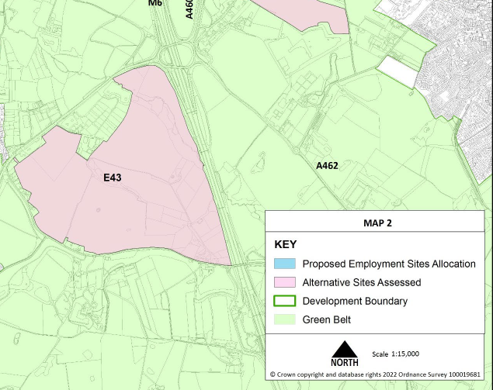

1. JLL advised through the submission of the Technical Note on Deliverability in August 2020 that the site’s boundaries extended to cover the full frontage of the A460. The situation plan from the Technical Note on delivery is extracted and provided overleaf: -

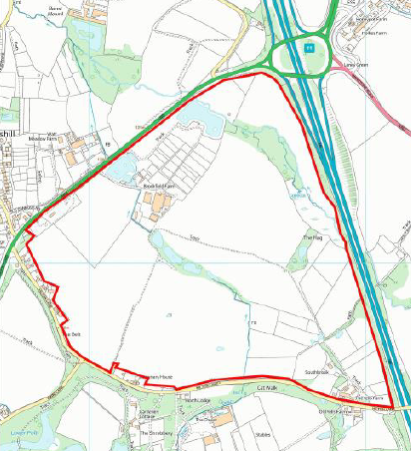

1. The inclusion of all the land fronting the A460 presents a better overall development opportunity and should be factored in any reassessment of the site.
2. The conclusions to the site assessment for Site E43 in the 2022 Topic Paper notes that:

“*The site performs relatively well and has a clear advantage for distribution/logistics of being close to the M6 (Junction 11). However, major negative effects are also predicted in the sustainability appraisal, due to the site being in one of the more harmful Green Belt areas within the district”.*

1. The assessment to the site selection criteria of Green Belt harm is “high”.
2. This rating inexplicitly ignores the effect of the M54/M6 link road on the site. The South Staffordshire Green Belt Study (conducted in 2019) did not take this into account. As part of the consultation response to the South Staffordshire Spatial Housing Strategy and Infrastructure Delivery (in December 2019), JLL submitted an assessment by independent consultants, Tyler Grange, on the contribution the site would make to the Green Belt. This response is included as **Enclosure No. 3**. This assessment downgraded the land between the A460 and the link road as “moderate-high” and between the link road and the M6 motorway as “moderate”.
3. The impact of the link road on the contribution the site makes to the Green Belt can be gauged by the plan below, which shows the routing of the proposed link road through the site. It will clearly compromise the openness of this part of the Green Belt.

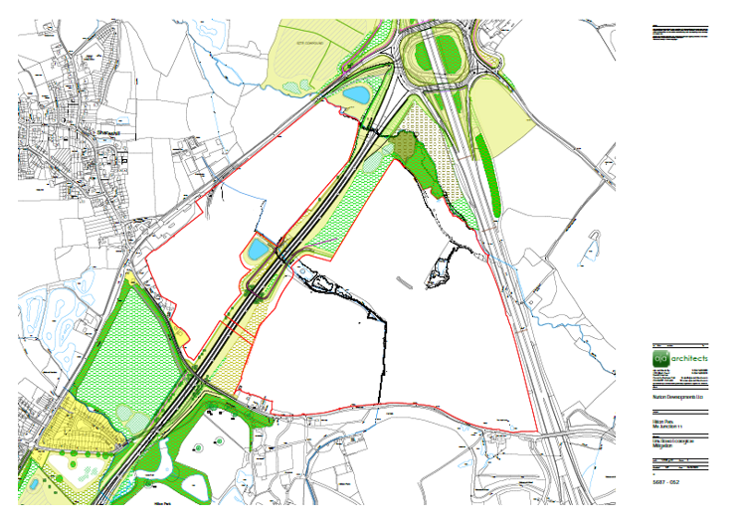

1. An addendum to the Green Belt Study has been produced this year. However, despite JLL’s representations to the Preferred Options pointing to this obvious omission, it still does not address this point. Instead, it concentrates on assessing a new housing site.
2. Had the site been properly assessed then its merits would be clear.

**Box 6 – Suggested Modifications**

1. The plan needs to identify and allocate new sites to meet the shortfall of available development land to meet local needs. This shortfall has been identified by JLL to be at least 90 hectares.
2. In addition, South Staffordshire needs to work collaboratively with the Black Country local planning authorities to ensure a sufficient quantity and quality of employment development is brought forward to meet wider employment needs of its FEMA. This should include freestanding strategic employment sites, given the lack of such sites serving the Black Country and the recommendations of the West Midlands Strategic Employment Sites Study of 2021.
3. Hilton Park, at Junction 11, M6, is an obvious candidate for a new freestanding strategic employment site. It is well located, is closely related to planned infrastructure improvements (i.e the M54/M6 link road) and has scale. It provides a developable area of 43 hectares and could be delivering new industrial and warehouse units by 2025. It is well suited to meet both local and wider market needs and was ranked very highly by the West Midlands Strategic Employment Site Study of 2021 as a potential new strategic development opportunity.
4. This development opportunity should be reassessed by the Council prior to allocating additional sites, through Policy SA7, to meet fully the needs for new employment development land for the district.

**PJL**

**JLL**

**19 December 2022**