|  |  |  |
| --- | --- | --- |
|  | **Local Plan**  Publication Stage  Representation Form | **Ref:**      **(For official use only)** |

|  |
| --- |
| **South Staffordshire Council Local Plan 2023 - 2041** |

**Name of the Local Plan to which this representation relates:**

**Please return to South Staffordshire Council by 12 noon Friday 31 May 2024**

This form has two parts –

Part A – Personal Details: need only be completed once.

Part B – Your representation(s). Please fill in a separate sheet for each representation you wish to make.

# Part A

1. Personal 2. Agent’s Details (if Details* applicable)

\**If an agent is appointed, please complete only the Title, Name and Organisation (if applicable)* *boxes below but complete the full contact details of the agent in 2.*

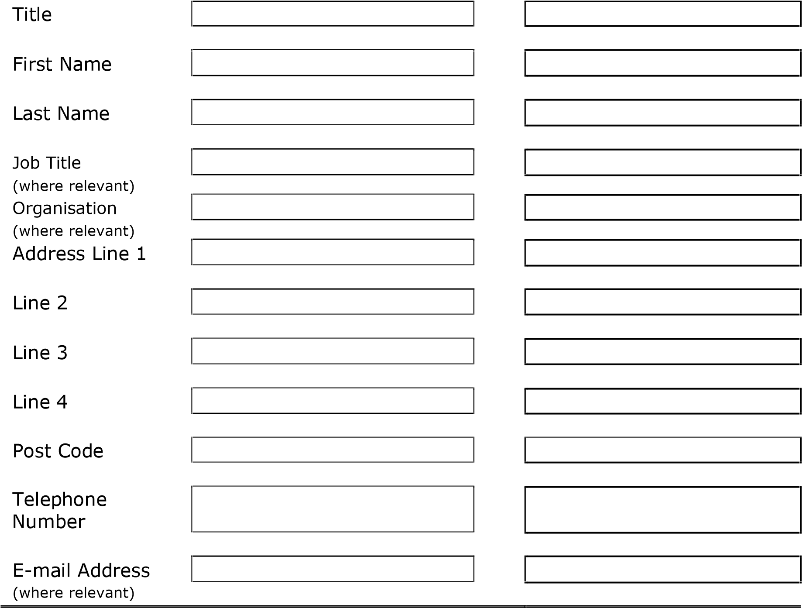

Personal - Mrs Jennifer Cree, Parish Clerk, Kinver Parish Council, 95 High Street, Kinver, DY7 6HD. 01384873878 clerk@kinver-pc.gov.uk

# Part B – Please use a separate sheet for each representation

Name or Organisation: Kinver Parish Council

1. To which part of the Local Plan does this representation relate?

|  |  |  |  |  |
| --- | --- | --- | --- | --- |
|  | Policy | SA3 | Policies Map | 274 a/b |

Paragraph

1. Do you consider the Local Plan is :

|  |  |  |
| --- | --- | --- |
|  | No    No |  |
|  |  |
|  |  |

1. Legally compliant Yes

1. Sound Yes
2. Complies with the

|  |
| --- |
|  |

|  |
| --- |
|  |

Duty to co-operate Yes No

Please tick as appropriate

1. Please give details of why you consider the Local Plan is not legally compliant or is unsound or fails to comply with the duty to co-operate. Please be as precise as possible.

If you wish to support the legal compliance or soundness of the Local Plan or its compliance with the duty to co-operate, please also use this box to set out your comments.

Part B: Site Allocations p52:

Policy SA3 Housing Allocations and Housing Site Selection Topic Paper 2024

RE site 274 : Land South of White Hill

Comparing site assessments in the area, we note that this site is listed as ‘no major negative or positive effects are predicted’ where for other, less prominently visible, less locally important sites, in less sensitive positions, the assessment admits to landscape damage. Several other factors, listed below, indicate that when applying the criteria consistently the proposed site would not have been considered favourable for development.

Furthermore, if the site is developed, these factors would require careful attention and mitigation to minimise damage. These factors include:

Heritage and Landscape damage.

o The land lies just below Kinver Edge, and is prominently visible from the toposcope viewpoint. It provides the only green/rural foreground to views of the Kinver Edge escarpment.

• Biodiversity and wildlife damage:

o The Sandscapes project led by the National Trust and Staffordshire Wildlife Trust, to link areas of lowland heath, seeks to re-establish, protect and link areas of the rare lowland heath mosaic habitat. This site is within an area of strategic importance to strengthen links between Kinver Edge and Highgate Common.

o The Kinver Neighbourhood Plan Nature Recovery Report by Staffordshire Wildlife Trust identifies this site as being on one of the narrower parts of the Heathland Habitat Connectivity Opportunity Area identified in this report. Restoration and creation of heathland mosaic is stated as a priority. Establishment of heathland mosaic on or adjacent to this land would greatly contribute to the value of this corridor.

o Protection of hedgerows, trees, and the boundary with adjacent green spaces is vital

• Amenity loss or damage

o The site includes an early section of the Staffordshire Way long distance footpath. The proposed development would create urban surroundings for this beautiful path.

o The site has for long been used as a recreational / walking area for local people, being readily accessible, on foot and without climbing a steep ascent. Loss of this amenity has not been taken into account in the assessment, nor is it clear how such usage would be protected at this location, for local people. We note that policy HC19 of the proposed Local Plan seeks to protect such sites.

• Access to facilities and Active travel:

o Such a large increase in housing will cause a corresponding increase in car journeys given the limited public transport and facilities. This is counter to current policies.

o Provision for walking and cycling is currently poor (narrow roads and pavements, and the only reasonable exit from the site being via a congested and potentially dangerous junction by local schools, at Potter’s Cross).

o The scale of proposed development would not result in improvements or additional infrastructure, making the settlement unsustainable in a rural location.

We also note that during previous consultations on both the Kinver Neighbourhood Plan and the Local Plan 2022, there was substantial local opposition to development of site 274, both with respect to site location and scale.

One recurring local concern is the ability of the nearby White Hill/Meddins Lane/Enville Road junctions to absorb the additional vehicular traffic from this site, especially during the pick-up/drop-off times at the adjacent Brindley and Kinver High schools. This junction will be on the primary route to and from the development. Within the last 12 months one child has been injured by a moving car as they negotiated cars obstructing the pavement and we would expect to see any proposal for the development of this site to be accompanied by proposals to safeguard pedestrian, especially school age pedestrian, safety at this junction.

274a is currently being developed, and the impact of this on the local area has not yet had chance to be monitored / observed. Once 274a has been completed the capacity of the local area to cope with the additional traffic and surface water run off needs to be to be tested / re-assessed before any further development takes place especially 274b.

(Continue on a separate sheet /expand box if necessary)

1. Please set out the modification(s) you consider necessary to make the Local Plan legally compliant and sound, in respect of any legal compliance or soundness matters you have identified at 5 above. (Please note that non-compliance with the duty to co-operate is incapable of modification at examination). You will need to say why each modification will make the Local Plan legally compliant or sound. It will be helpful if you are able to put forward your suggested revised wording of any policy or text. Please be as precise as possible.

(Continue on a separate sheet /expand box if necessary)

***Please note:*** *In your representation you should provide succinctly all the evidence and supporting information necessary to support your representation and your suggested modification(s). You should not assume that you will have a further opportunity to make submissions.*

***After this stage, further submissions may only be made if invited by the Inspector, based on the matters and issues he or she identifies for examination.***

1. If your representation is seeking a modification to the plan, do you consider it necessary to participate in examination hearing session(s)?

|  |  |  |
| --- | --- | --- |
|  | **No**, I do not wish to participate in hearing session(s) |  |

**Yes**, I wish to

participate in

hearing session(s)

|  |  |  |  |  |
| --- | --- | --- | --- | --- |
| |  | | --- | | Please note that while this will provide an initial indication of your wish to | | |  | |
| |  | | --- | | participate in hearing session(s), you may be asked at a later point to confirm | | | |  |
| your request to participate. |  | |

1. If you wish to participate in the hearing session(s), please outline why you consider this to be necessary:

|  |
| --- |
|  |

***Please note*** *the Inspector will determine the most appropriate procedure to adopt to hear those who have indicated that they wish to participate in*  *hearing session(s). You may be asked to confirm your wish to participate when the Inspector has identified the matters and issues for examination.*

**Representations cannot be kept confidential and will be available for public scrutiny, including your name and/or organisation (if applicable). However, your contact details will not be published.**

**Data Protection**

Your details will be added to our Local Plans Consultation database so that we can contact you as the review progresses. South Staffordshire Council will process your personal data in accordance with the Data Protection Act 2018 and the General Data

## Protection Regulations (GDPR). Our Privacy Notice can be viewed at [Data Protection (Strategic Planning) | South Staffordshire District Council (sstaffs.gov.uk)](https://www.sstaffs.gov.uk/planning/planning-policy/data-protection-strategic-planning)

Please return the form via email to localplans@sstaffs.gov.uk or by post to South

Staffordshire Council, Community Hub, Wolverhampton Road, Codsall, South Staffordshire WV8 1PX